**User Guide**

**DEMOGRAPHY**



USER GUIDE – DEMOGRAPHY

*Modern Statistics Platform*

**Revision History**

|  |  |  |  |
| --- | --- | --- | --- |
| Name | Date | Reasons of Changes | Version |
| iTM | 08th December 2023 | The first draft of Demography MauStats. | V1 |
| iTM | 18th June 2024 | The second draft of Demography MauStats. | V2 |
| iTM | 10th September 2024 | The third draft of Demography MauStats. | V3 |

Table of Contents

1.0 INTRODUCTION 4

2.0 DEMOGRAPHY 5

2.1 LIVE BIRTH 5

2.1.1 ADD 6

2.1.2 FILTER 10

2.2 STILL BIRTH 12

2.2.1 ADD 13

2.2.2 FILTER 17

2.3 MARRIAGE 19

2.3.1 ADD 20

2.3.2 FILTER 25

2.4 DEATH 27

2.4.1 ADD 28

2.4.2 FILTER 32

2.5 ANNEXURE 34

# 1.0 INTRODUCTION

The Modern Statistics (MauStats) Platform is developed as a web-based platform with a central database to ensure consistency, security, and accessibility. The platform will help to automate and integrate the data lifecycle from acquisition to dissemination using the Generic Statistical Business Process Model (GSBPM) framework. The platform complies with managing data requirements for Census, SEE, SBR, Demography, and Trade processed data in this phase. It is also feasible for data integration based on SM requirements. This web-based platform consists of two applications – User Interface and Data Management System (DMS).

In this user guide, we will be learning how to use the Demography module of the DMS application. The Demography module comprises four submodules, each corresponding to a specific vital data category received from the Central Statistics Office (CSO). Each submodule is tailored to manage a specific dataset: **Live Birth**, **Still Birth**, **Marriage**, and **Death**.

The below section explains the features and steps of using the Demography module.

# 2.0 DEMOGRAPHY

The Demography module comprises four submodules – **Live Birth,** **Still Birth**, **Marriage**, and **Death**. The module is developed to manage the population vitals data.

Let us learn how to use these submodules in detail.

## 2.1 LIVE BIRTH

This submodule allows authorized users to create and manage **Live Birth** data records.

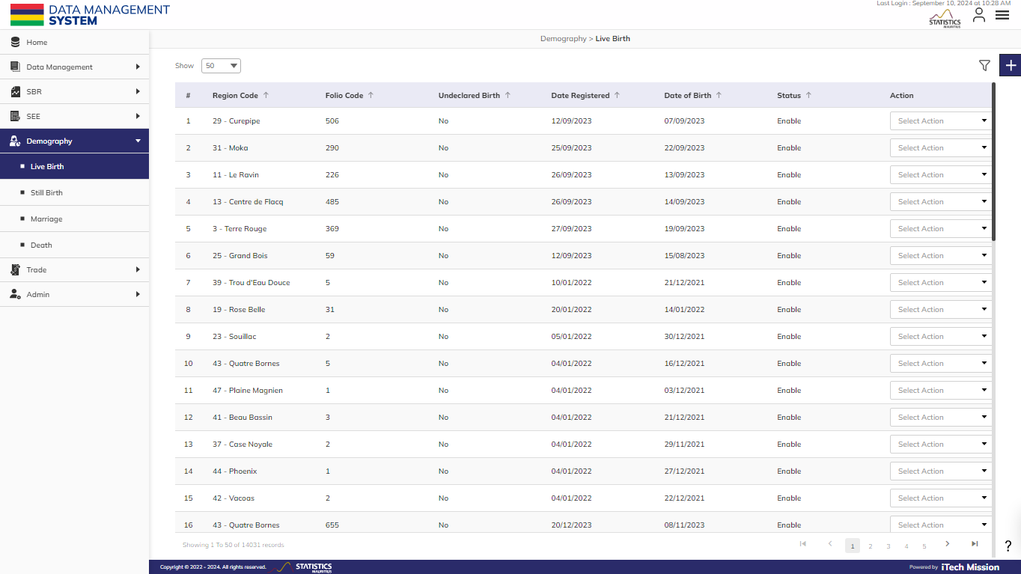**Step 1:** Click on the **Live Birth** option available under the Demography module to access this sub-module. You have the option to add, edit, enable/disable, delete, and filter the **Live Birth** records. You also have the option to search, sort, and view the existing records by page (see below figure).

### 2.1.1 ADD

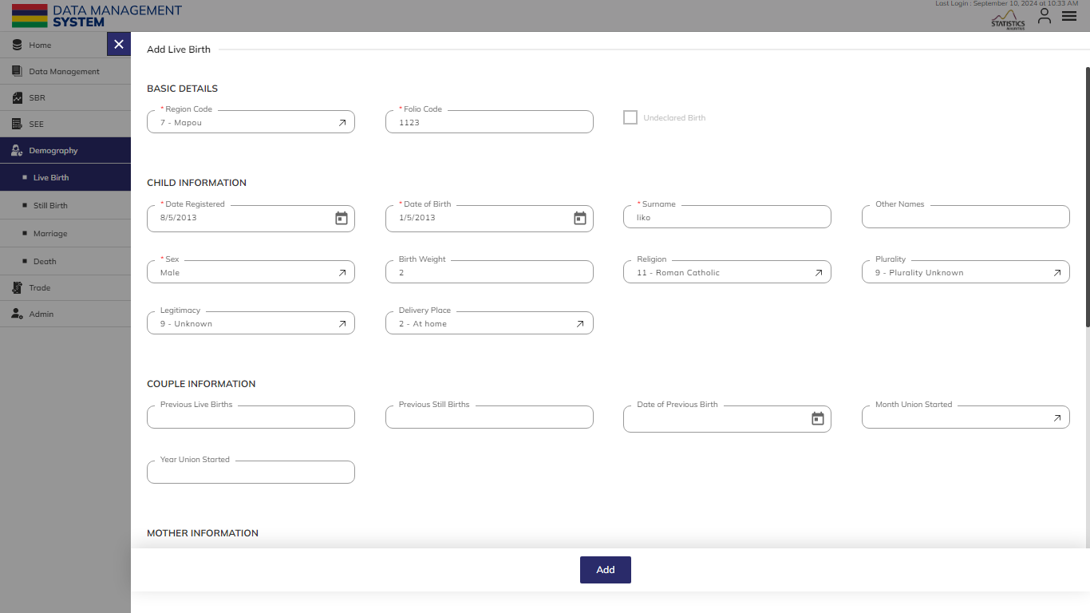**Step 2:** Click on the **Plus** button available on the right side of the page to add a new **Live Birth** record (see figure below).

The Add **Live Birth** form is divided into sections namely – **Basic Details**, **Child Information**, **Couple Information**, **Mother Information**, **Father Information,** and **Address Information**.

Enter the following information to add a new **Live Birth** record –

|  |  |  |  |  |
| --- | --- | --- | --- | --- |
| **Field** | **Type** | **Import Type** | **Mandatory** | **Associated Classification** |
| **Region Code** | List | Single Choice | Yes | Civil status region codes |
| **Folio Code** | Text | Limit up to 6 characters | Yes |  |
| the child's **Date Registered** | Date | Format – DD/MM/YYYY while importing | Yes |  |
| the child's **Date of Birth** | Date | Can be up to 60 days before the date registered | Yes |  |
| the child's **Surname** | Text |  | Yes |  |
| the child’s **Other Names** | Text |  | No |  |
| the child’s **Sex** | List | Single Choice | Yes | Gender Codes |
| the child's **Birth Weight** | Number | Limit up to 3 characters | No |  |
| the child's **Religion** | List | Single Choice | No | Civil status religion codes |
| the child's **Plurality** | List | Single Choice | No | Civil status plurality codes |
| the child's **Legitimacy** | List | Single Choice | No | Civil status legitimacy codes |
| the child's **Delivery Place** | List | Single Choice | No | Civil status place of delivery codes |
| the couple's **Previous Live Births** | Number | Limit up to 2 characters | No |  |
| the couple's **Previous Still Births** | Number | Limit up to 2 characters | No |  |
| **Date of Previous Birth** | Date | Format – DD/MM/YYYY while importing | No |  |
| **Month Union Started** | List | Single Choice | No | Month Union Started |
| **Year Union Started** | Number | Limit up to 4 characters | No |  |
| the mother's **Age** | Number | Limit up to 2 characters | No |  |
| the mother's **Date of Birth** | Date | Format – DD/MM/YYYY while importing | No |  |
| the mother's **Nationality Code** | List | Single Choice | No | Civil status nationality codes |
| the mother's **Occupation** | List | Single Choice | No | Occupation Demography |
| the mother's **Occupation (French)** | Text | Single Choice | No |  |
| The mother’s **Occupation Code** | List | Auto-generated | No | Occupation (NASCO) |
| The mother’s **Employment Status** | List | Auto-generated | No | Employment status |
| the father's **Age** | Number | Limit up to 2 characters | No |  |
| the father's **Date of Birth** | Date | Format – DD/MM/YYYY while importing | No |  |
| the father's **Nationality Code** | List | Single Choice | No | Civil status nationality codes |
| the father's **Occupation** | List | Single Choice | No | Occupation Demography |
| the father's **Occupation (French)** | Text |  | No |  |
| The father's **Occupation Code** | List | Auto-generated | No | Occupation (NASCO) |
| The father's **Employment Status** | List | Auto-generated | No | Employment status |
| **Address 1** | Text |  | No |  |
| **Address 2** | Text |  | No |  |
| **Address 3** | Text |  | No |  |
| **Address 4** | Text |  | No |  |
| **Address 5** | Text |  | No |  |
| **District Code** | List | Single Choice | No | Civil status district codes |
| **VCA Code** | List | Single Choice | No | MVCA |

Click on the **Add** button to save and confirm. You can now view the new **Live Birth** record added to the list.

**Step 3:** Selectthe **View** option available in the action dropdown to view the details of the selected element.

**Step 4:** Selectthe **Edit** option available in the action dropdown to edit the details of the selected element. Edit the required detail and click on the **update** button to save and confirm.

**Step 5:** Selectthe **Delete** option available in the action dropdown to delete the selected element. A confirmation popup appears, click **yes** to confirm the deletion of the selected element.

**Step 6:** Select the **Enable/Disable** option available in the action dropdown to show or hide the specific element. The hidden element will not be shown throughout the application.

### 2.1.2 FILTER

**Step 7:** Click the **Filter** button on the right side of the page to filter the **Live Birth** list based on the specified criteria.

Suppose you want to **Filter** the record where the “Region Code” is “equal to” <49-Port Mathurin>.

The above statement comprises -

* Enter **Filter Name**
* “Region Code “as **Column**
* “Equal to (=)” as **Operator**
* <49-Port Mathurin> as **Value**

*All the blue color details are mandatory to be entered.*

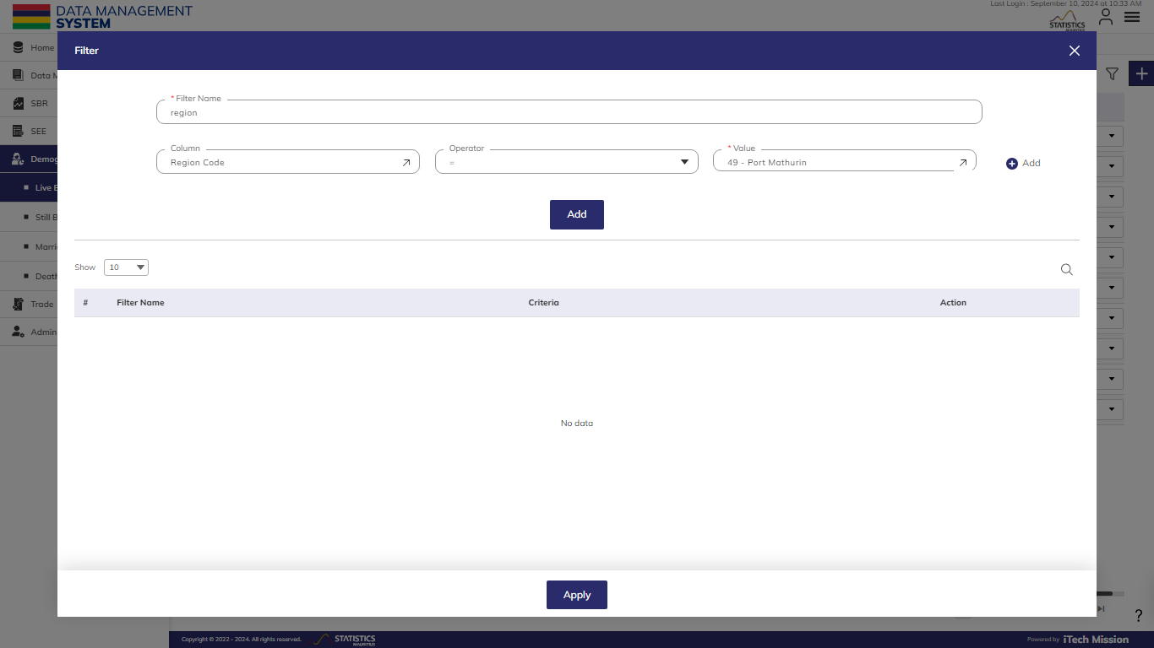Click on the **Add** button to confirm saving the **Filter**. You can apply multiple criteria by adding multiple **Filter**s one by one following a similar approach to add each one separately. You can also add multiple **Filter**s at once by clicking on the **Plus** button available in the first **Filter** row (see below figure).

**NOTE:**

To filter a dataset based on multiple conditions, if you need all conditions to be true (e.g., records where religion is 11 - Roman Catholic **AND** sex is male), apply the filters separately. For conditions where one of the conditions needs to be true (e.g., records where religion is 11 - Roman Catholic **OR** sex is male), combine the filters.

Click on the **Apply** button to **Filter** the **Live Birth** list based on saved **Filter**s.

## 2.2 STILL BIRTH

This submodule allows authorized users to create and manage **Still Birth** data records.

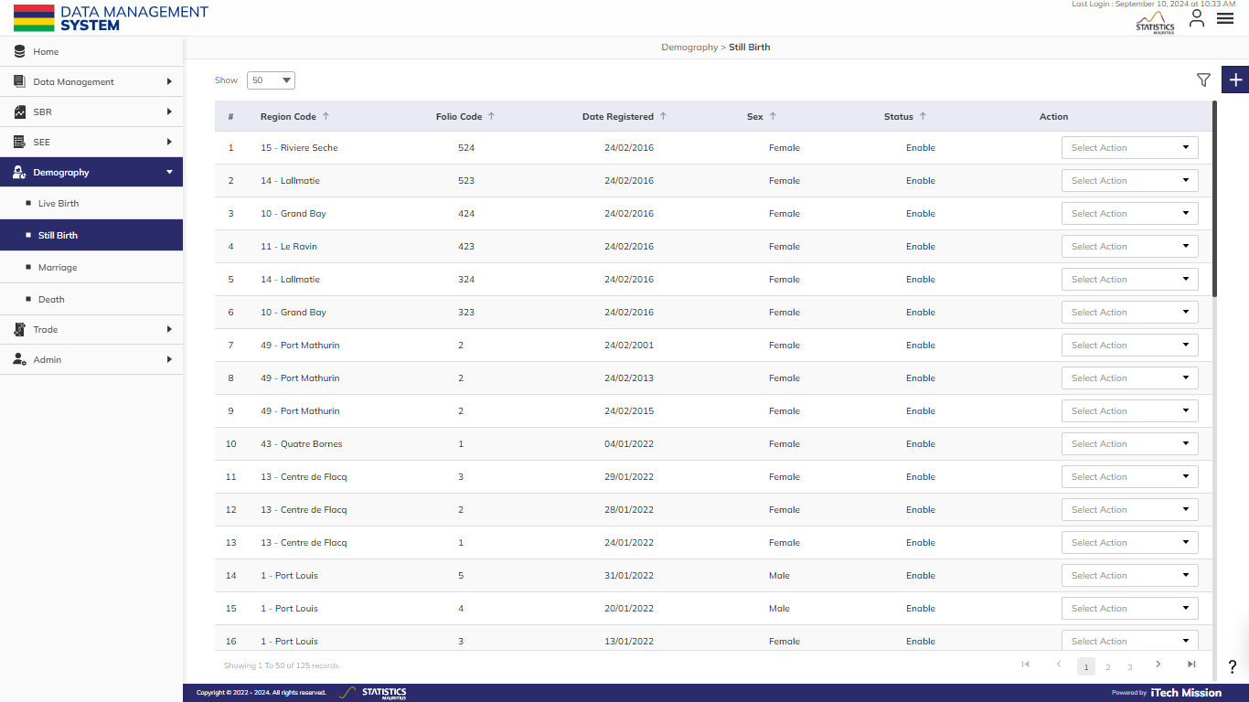**Step 8:** Click on the **Still Birth** option available under the Demography module to access this sub-module. You have the option to add, edit, disable/enable, delete, and filter the **Still Birth** records. You also have the option to search, sort, and view the existing records by page.

### 2.2.1 ADD

****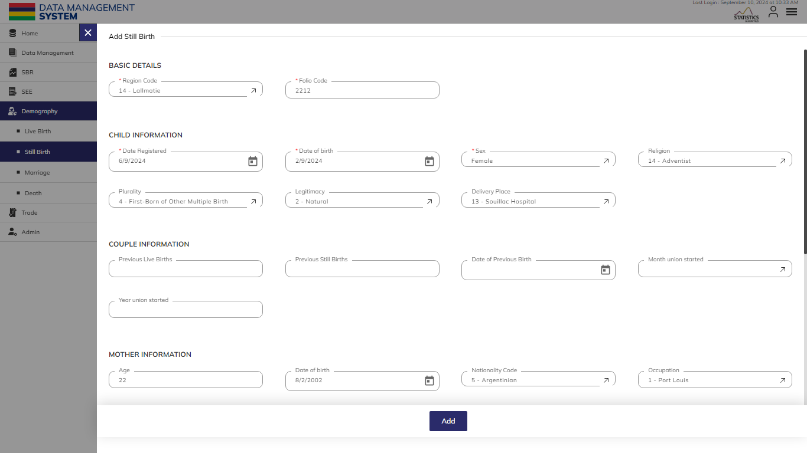**Step 9:** Click on the **Plus** button available on the right side of the page to add a new **Still Birth** record (see figure below).

The Add **Still Birth** form is divided into sections namely – **Basic Details**, **Child Information**, **Couple Information**, **Mother Information**, **Father Information,** and **Address Information**.

Enter the following information to add a new **Still Birth** record –

|  |  |  |  |  |
| --- | --- | --- | --- | --- |
| **Field** | **Type** | **Import Type** | **Mandatory** | **Associated Classification** |
| **Region Code** | List | Single Choice | Yes | Civil status region codes |
| **Folio Code** | Text | Limit up to 6 characters | Yes |  |
| the child's **Date Registered** | Date | Format – DD/MM/YYYY while importing | Yes |  |
| the child's **Date of Birth** | Date | Can be up to 60 days before the date registered | Yes |  |
| the child’s **Sex** | List | Single Choice | Yes | Gender Codes |
| the child's **Religion** | List | Single Choice | No | Civil status religion codes |
| the child's **Plurality** | List | Single Choice | No | Civil status plurality codes |
| the child's **Legitimacy** | List | Single Choice | No | Civil status legitimacy codes |
| the child's **Delivery Place** | List | Single Choice | No | Civil status place of delivery codes |
| the couple's **Previous Live Births** | Number | Limit up to 2 characters | No |  |
| the couple's **Previous Still Births** | Number | Limit up to 2 characters | No |  |
| **Date of Previous Birth** | Date | Format – DD/MM/YYYY while importing | No |  |
| **Month Union Started** | List | Single Choice | No | Month Union Started |
| **Year Union Started** | Number | Limit up to 4 characters | No |  |
| the mother's **Age** | Number | Limit up to 2 characters | No |  |
| the mother's **Date of Birth** | Date | Format – DD/MM/YYYY while importing | No |  |
| the mother's **Nationality Code** | List | Single Choice | No | Civil status nationality codes |
| the mother's **Occupation** | List | Single Choice | No | Occupation Demography |
| the mother's **Occupation (French)** | Text |  | No |  |
| The mother’s **Occupation Code** | List | Auto-generated | No | Occupation (NASCO) |
| The mother’s **Employment Status** | List | Auto-generated | No | Employment status |
| the father's **Age** | Number | Limit up to 2 characters | No |  |
| the father's **Date of Birth** | Date | Format – DD/MM/YYYY while importing | No |  |
| the father's **Nationality Code** | List | Single Choice | No | Civil status nationality codes |
| the father's **Occupation** | List | Single Choice | No | Occupation Demography |
| the father's **Occupation (French)** | Text |  | No |  |
| The father's **Occupation Code** | List | Auto-generated | No | Occupation (NASCO) |
| The father's **Employment Status** | List | Auto-generated | No | Employment status |
| **Address 1** | Text |  | No |  |
| **Address 2** | Text |  | No |  |
| **Address 3** | Text |  | No |  |
| **Address 4** | Text |  | No |  |
| **Address 5** | Text |  | No |  |
| **District Code** | List | Single Choice | No | Civil status district codes |
| **VCA Code** | List | Single Choice | No | MVCA |

Click on the **Add** button to save and confirm. You can now view the new record added to the list.

**Step 10:** Selectthe **View** option available in the action dropdown to view the details of the selected element.

**Step 11:** Selectthe **Edit** option available in the action dropdown to edit the details of the selected element. Edit the required detail and click on the update button to save and confirm.

**Step 12:** Selectthe **Delete** option available in the action dropdown to delete the selected element. A confirmation popup appears, click yes to confirm the deletion of the selected element.

**Step 13:** Select the **Enable/Disable** option available in the action dropdown to show or hide the specific element. The hidden element will not be shown throughout the application.

### 2.2.2 FILTER

**Step 14:** Click the **Filter** button on the right side of the page to filter the **Still Birth** list based on the specified criteria.

Suppose you want to **Filter** the record where the “Region Code” is “equal to” <49-Port Mathurin>.

The above statement comprises -

* Enter **Filter Name**
* “Region Code “as **Column**
* “Equal to (=)” as **Operator**
* <49-Port Mathurin> as **Value**

*All the blue color details are mandatory to be entered.*

Click on the **Add** button to confirm saving the **Filter**. You can apply multiple criteria by adding multiple **Filter**s one by one following a similar approach to add each one separately. You can also add multiple **Filter**s at once by clicking on the **Plus** button available in the first **Filter** row (see below figure).

**NOTE:**

To filter a dataset based on multiple conditions, if you need all conditions to be true (e.g., records where religion is 11 - Roman Catholic **AND** sex is male), apply the filters separately. For conditions where one of the conditions needs to be true (e.g., records where religion is 11 - Roman Catholic **OR** sex is male), combine the filters.

Click on the **Apply** button to **Filter** the **Still Birth** list based on saved **Filter**s.

## 2.3 MARRIAGE

This submodule allows the authorized users to create and manage the **Marriage** data records.

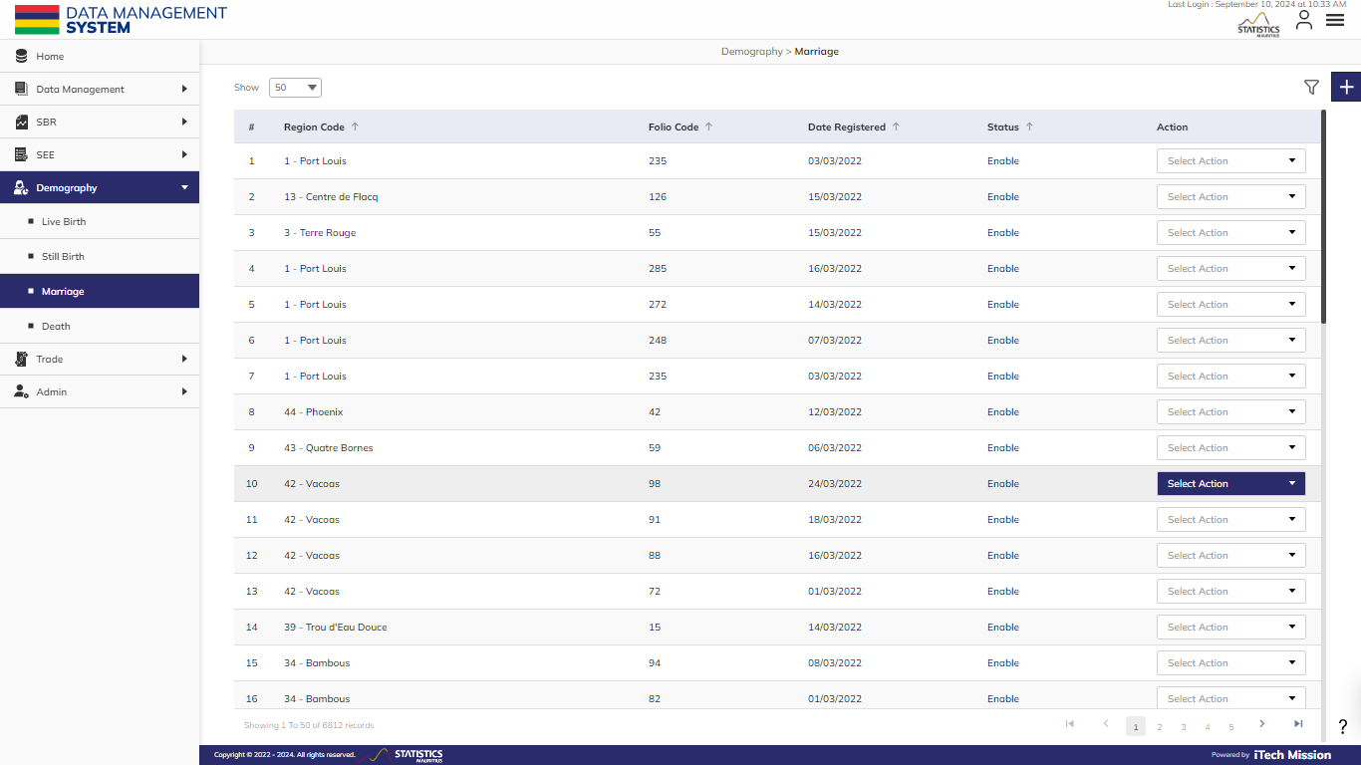**Step 15:** Click on the **Marriage** option available under the Demography module to access this sub-module. You have the option to add, edit, disable/enable, delete, and filter the **Marriage** records. You also have the option to search, sort, and view the existing records by page.

### 2.3.1 ADD

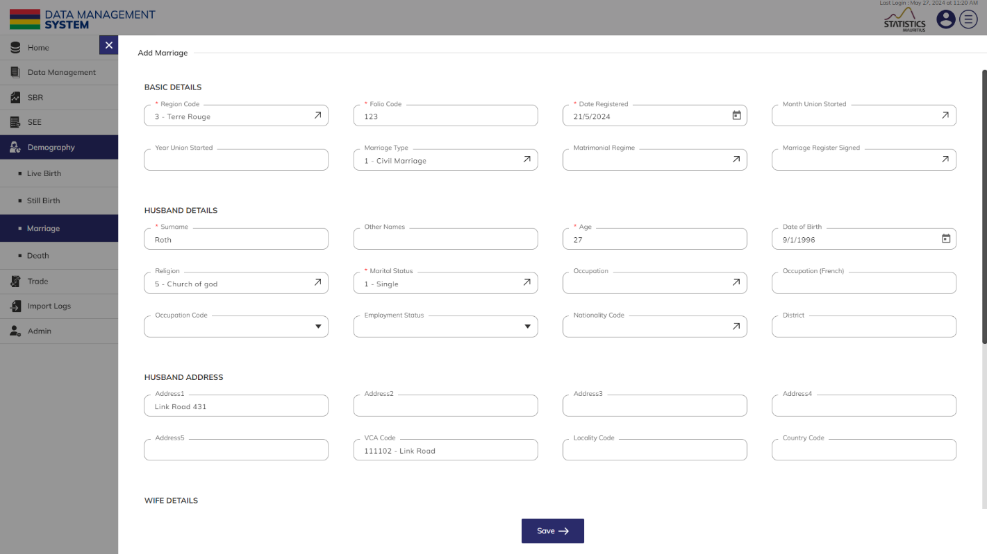**Step 16:** Click on the **Plus** button available on the right side of the page to add a new **Marriage** record (see figure below).

The Add **Marriage** form is divided into sections namely – **Basic Details**, **Husband Details**, **Husband Address**, **Wife Details,** and **Wife** **Address**.

Enter the following information to add a new **Marriage** record –

|  |  |  |  |  |
| --- | --- | --- | --- | --- |
| **Field** | **Type** | **Import Type** | **Mandatory** | **Associated Classification** |
| **Region Code** | List | Single Choice | Yes | Civil status region codes |
| **Folio Code** | Text | Limit up to 6 characters | Yes |  |
| the child's **Date Registered** | Date | Format – DD/MM/YYYY while importing | Yes |  |
| **Month Union Started** | List | Single Choice | No | Month Union Started |
| **Year Union Started** | Number | Limit up to 4 characters | No |  |
| **Marriage Type** | List | Single Choice | No | Civil status marriage type codes |
| **Matrimonial Regime** | List | Single Choice | No | Civil status matrimonial regime codes |
| **Marriage Register Signed** | List | Single Choice | No | Civil status marriage register signed codes |
| the Husband's **Surname** | Text |  | Yes |  |
| the Husband's **Other Names** | Text |  | No |  |
| the Husband's **Age** | Number | Limit up to 2 characters | Yes |  |
| the Husband's **Date of Birth** | Date | Format – DD/MM/YYYY while importing | No |  |
| the Husband's **Religion** | List | Single Choice | No |  |
| the Husband's **Marital Status** | List | Single Choice | Yes |  |
| the Husband's **Occupation** | List | Single Choice | No | Occupation Demography |
| the Husband's **Occupation (French)** | Text |  | No |  |
| The Husband's **Occupation Code** | List | Auto-generated | No | Occupation (NASCO) |
| The Husband's **Employment Status** | List | Auto-generated | No | Employment status |
| the Husband's **Nationality Code** | List | Single Choice | No | Civil status nationality codes |
| the Husband's **District** | List | Single Choice | No |  |
| the Husband's **Address 1** | Text |  | No |  |
| the Husband's **Address 2** | Text |  | No |  |
| the Husband's **Address 3** | Text |  | No |  |
| the Husband's **Address 4** | Text |  | No |  |
| the Husband's **Address 5** | Text |  | No |  |
| the Husband's **VCA Code** | List | Single Choice | No | MVCA |
| the Husband's **Locality Code** | Text | Limit up to 4 characters | No |  |
| the Husband's **Country Code** | Text | Limit up to 4 characters | No |  |
| the Wife’s **Surname** | Text |  | Yes |  |
| the Wife’s **Other Names** | Text |  | No |  |
| the Wife’s **Age** | Number | Limit up to 2 characters | Yes |  |
| the Wife’s **Date of Birth** | Date | Format – DD/MM/YYYY while importing | No |  |
| the Husband's **Religion** | List | Single Choice | No |  |
| the Wife’s **Marital Status** | List | Single Choice | Yes |  |
| the Wife’s **Occupation** | List | Single Choice | No | Occupation Demography |
| the Wife’s **Occupation (French)** | Text |  | No |  |
| The Wife’s **Occupation Code** | List | Auto-generated | No | Occupation (NASCO) |
| The Wife’s **Employment Status** | List | Auto-generated | No | Employment status |
| the Wife’s **Nationality Code** | List | Single Choice | No | Civil status nationality codes |
| the Wife’s **District** | List | Single Choice | No |  |
| the Wife’s **Address 1** | Text |  | No |  |
| the Wife’s **Address 2** | Text |  | No |  |
| the Wife’s **Address 3** | Text |  | No |  |
| the Wife’s **Address 4** | Text |  | No |  |
| the Wife’s **Address 5** | Text |  | No |  |
| the Wife’s **VCA Code** | List | Single Choice | No | MVCA |
| the Wife’s **Locality Code** | Text | Limit up to 4 characters | No | Civil status district codes |
| the Wife’s **Country Code** | Text | Limit up to 4 characters | No | Civil status district codes |

Click on the **Save** button to save and confirm. You can now view the new record added to the list.

**Step 17:** Selectthe **View** option available in the action dropdown to view the details of the selected element.

**Step 18:** Selectthe **Edit** option available in the action dropdown to edit the details of the selected element. Edit the required detail and click on the update button to save and confirm.

**Step 19:** Select the **Delete** option available in the action dropdown to delete the selected element. A confirmation popup appears, click yes to confirm the deletion of the selected element.

**Step 20:** Click to select the **Enable/Disable** option available in the action dropdown to show or hide the specific element. The hidden element will not be shown throughout the application.

### 2.3.2 FILTER

**Step 21:** Click the **Filter** button on the right side of the page to filter the **Marriage** list based on the specified criteria.

Suppose you want to **Filter** the record where the “Region Code” is “equal to” <49-Port Mathurin>.

The above statement comprises –

* Enter **Filter Name**
* “Region Code “as **Column**
* “Equal to (=)” as **Operator**
* <49-Port Mathurin > as **Value**

*All the blue color details are mandatory to be entered.*

Click on the **Add** button to confirm saving the **Filter**. You can apply multiple criteria by adding multiple **Filter**s one by one following a similar approach to add each one separately. You can also add multiple **Filter**s at once by clicking on the **Plus** button available in the first **Filter** row (see below figure).

**NOTE:**

To filter a dataset based on multiple conditions, if you need all conditions to be true (e.g., records where religion is 11 - Roman Catholic **AND** sex is male), apply the filters separately. For conditions where one of the conditions needs to be true (e.g., records where religion is 11 - Roman Catholic **OR** sex is male), combine the filters.

Click on the **Apply** button to **Filter** the **Marriage** list based on saved **Filter**s.

## 2.4 DEATH

This submodule allows authorized users to create and manage the **Death** master list.

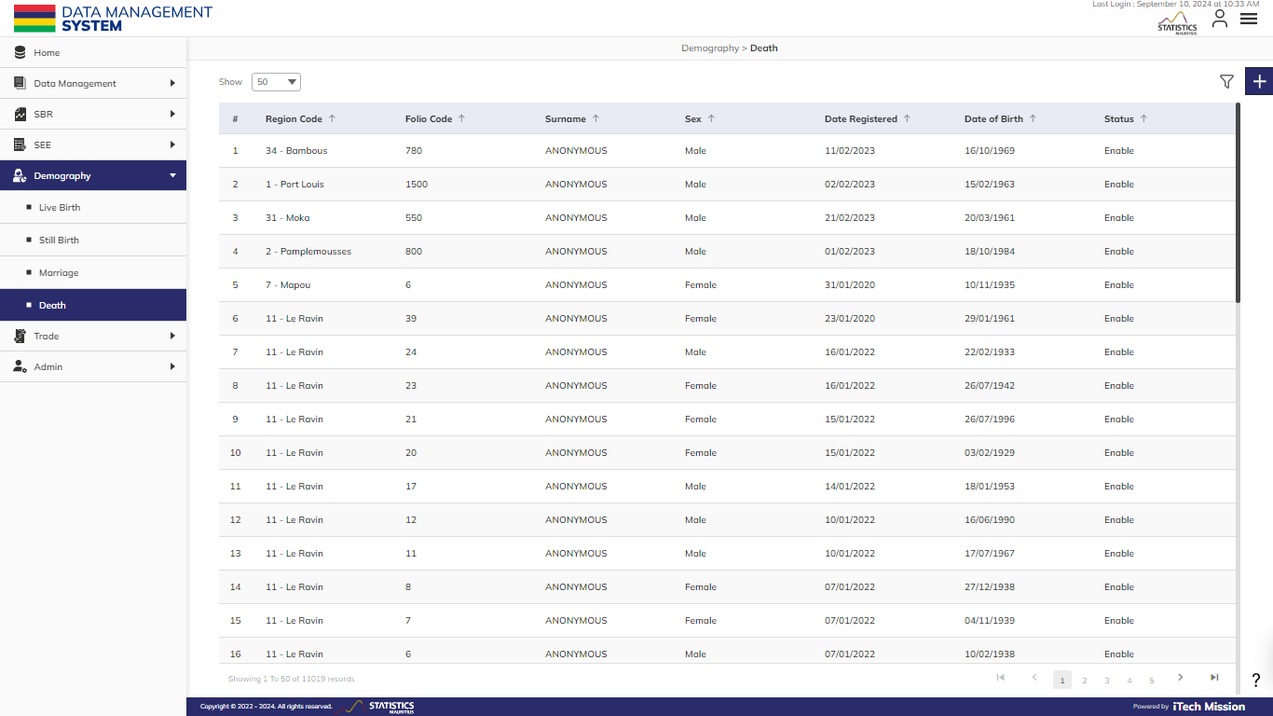**Step 22:** Click on the **Death** option available under the Demography module to access this sub-module. You have the options to add, edit, enable/disable, delete, and **Filter** the **Death** records. You also have the option to search, sort, and view the existing records by page.

### 2.4.1 ADD

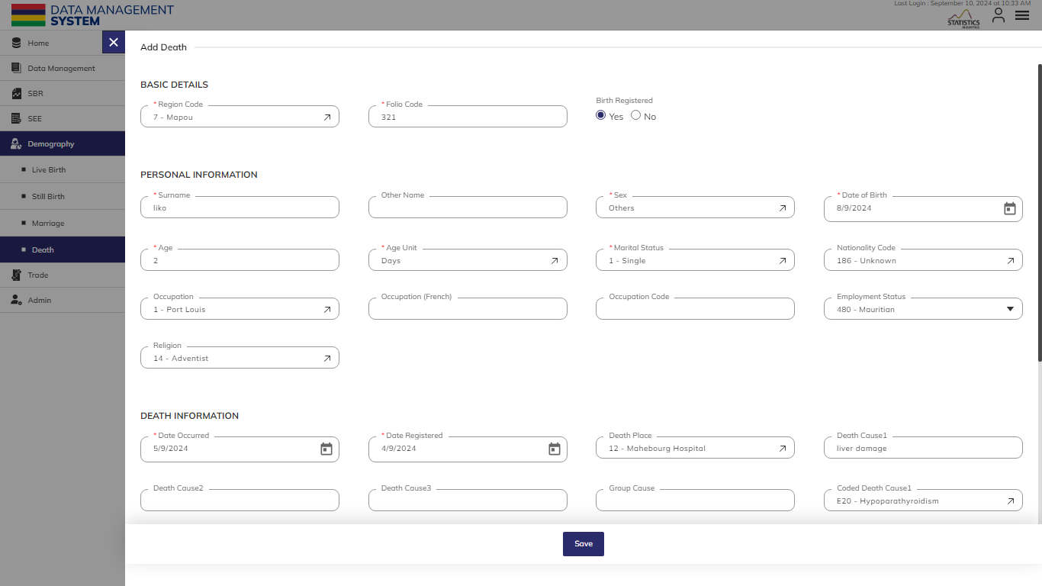**Step 23:** Click on the **Plus** button available on the right side of the page to add a new death record (see figure below).

The Add **Death** form is divided into sections namely – **Basic Details**, **Personal Information**, **Death Information,** and **Address Information**.

Enter the following information to add a new **Death** record –

|  |  |  |  |  |
| --- | --- | --- | --- | --- |
| **Field** | **Type** | **Import Type** | **Mandatory** | **Associated Classification** |
| **Region Code** | List | Single Choice | Yes | Civil status region codes |
| **Folio Code** | Text | Limit up to 6 characters | Yes |  |
| **Birth Registered** | Checkbox | Boolean (Yes or No as value while importing) |  |  |
| **Surname** | Text |  | Yes |  |
| **Other Names** | Text |  | No |  |
| **Sex** | List | Single Choice | Yes | Gender Codes |
| **Date of Birth** | Date | Format – DD/MM/YYYY while importing | Yes |  |
| **Age** | Number | Limit up to 2 characters | No |  |
| **Age Unit** | List | Single Choice | Yes | Age Unit |
| **Marital Status** | List | Single Choice | Yes | Civil status marital status codes |
| **Nationality Code** | List | Single Choice | No | Civil status nationality codes |
| **Occupation** | List | Single Choice | No | Occupation Demography |
| **Occupation (French)** | Text |  | No |  |
| **Occupation Code** | List | Auto-generated | No | Occupation (NASCO) |
| **Employment Status** | List | Auto-generated | No | Employment status |
| **Religion** | List | Single Choice | No | Civil status religion codes |
| Death **Occurred Date** | Date | Format – DD/MM/YYYY while importing | Yes |  |
| the death **Date Registered** | Date | Format – DD/MM/YYYY while importing | Yes |  |
| **Death Place** | List | Single Choice | No | Civil status place of death codes |
| **Death** **Cause 1** | Text | *(at least one death cause should be entered)* | No |  |
| **Death** **Cause 2** | Text |  | No |  |
| **Death** **Cause 3** | Text |  | No |  |
| **Death** **Cause 4** | Text |  | No |  |
| **Group Cause** | Text |  | No |  |
| **Coded Death Cause 1** | List | Single Choice | No | WHO Disease Code |
| **Coded Death Cause 2** | List | Single Choice | No | WHO Disease Code |
| **Coded Death Cause 3** | List | Single Choice | No | WHO Disease Code |
| the **Number of Live Birth** | Number | Limit up to 2 characters | No |  |
| a **Medical Certificate** | Checkbox | Boolean (Yes or No as value while importing) |  |  |
| **Address 1** | Text |  | No |  |
| **Address 2** | Text |  | No |  |
| **Address 3** | Text |  | No |  |
| **Address 4** | Text |  | No |  |
| **Address 5** | Text |  | No |  |
| **Township Code** | List | Single Choice | No | Civil status town codes |
| **District Code** | List | Single Choice | No | District Codes |
| **VCA Code** | List | Single Choice | No | MVCA |
| **Birth Country Code** | List | Single Choice | No | Birth Country Code |

Click on the **Save** button to save and confirm. You can now view the new record added to the list.

**Step 24:** Selectthe **View** option available in the action dropdown to view the details of the selected element.

**Step 25:** Select the **Edit** option available in the action dropdown to edit the details of the selected element. Edit the required detail and click on the update button to save and confirm.

**Step 26:** Select the **Delete** option available in the action dropdown to delete the selected element. A confirmation popup appears, click yes to confirm the deletion of the selected element.

**Step 27:** Click to select the **Enable/Disable** option available in the action dropdown to show or hide the specific element. The hidden element will not be shown throughout the application.

### 2.4.2 FILTER

**Step 28:** Click the **Filter** button on the right side of the page to filter the **Death** list based on the specified criteria.

Suppose you want to **Filter** the record where the “Region Code” is “equal to” <49-Port Mathurin>.

The above statement comprises -

* Enter **Filter Name**
* “Region Code “as **Column**
* “Equal to (=)” as **Operator**
* <49-Port Mathurin> as **Value**

*All the blue color details are mandatory to be entered.*

Click on the **Add** button to confirm saving the **Filter**. You can apply multiple criteria by adding multiple **Filter**s one by one following a similar approach to add each one separately. You can also add multiple **Filter**s at once by clicking on the **Plus** button available in the first **Filter** row (see below figure). 

**NOTE:**

To filter a dataset based on multiple conditions, if you need all conditions to be true (e.g., records where religion is 11 - Roman Catholic **AND** sex is male), apply the filters separately. For conditions where one of the conditions needs to be true (e.g., records where religion is 11 - Roman Catholic **OR** sex is male), combine the filters.

Click on the **Apply** button to **Filter** the **Death** list based on saved **Filter**s.

## 2.5 ANNEXURE

|  |  |  |
| --- | --- | --- |
| Death | Surname | If Cell is Blank, then put "ANONYMOUS" |
| Live Births | Child date of birth | Value >= 01.01.1900 and <=Current Date |
| Deaths | Date of birth | Value >= 01.01.1900 and <=Current Date |
| Still births | Child date of birth | Value >= 01.01.1900 and <=Current Date |
| Deaths | Birth Country Code | CIVIL_STATUS_COUNTRY_CODES |
| Live Births, Still Births. Marriage | Year Union Started | Year union started should be less or equal to date registered for birth |
| Deaths | Date of birth | Date of birth cannot be greater than date birth is registered |
| Deaths | Date occurred | Date occurred should be less or equal to date registered |
| All | Year Union Started | Value >= 1900 and <=Current Date |
| death | In Death Data, if 1. if "birthRegistered"=0 2. if age < 1 year | Register birth in "Live Births" Module |
| The combination of Region Code, Folio Code, and Registered Date are considered as a **unique record**. |  |  |
| The elements having **Birth registered** status ‘**NO**’ with an age less than 1 year, their data copy will be reflected in the live birth. |  |  |



USER GUIDE